What is an anal fissure?
An anal fissure is a tear in the lining of the anus, the opening where your bowel movements come out (figure 1). Anal fissures cause pain, especially during a bowel movement.
There is a muscle that wraps around the anus and holds it shut. It is called the "anal sphincter." The sphincter gets tense when the anus is injured. In people with anal fissures, the sphincter goes into spasms, which can lead to further injury.
Figure 1
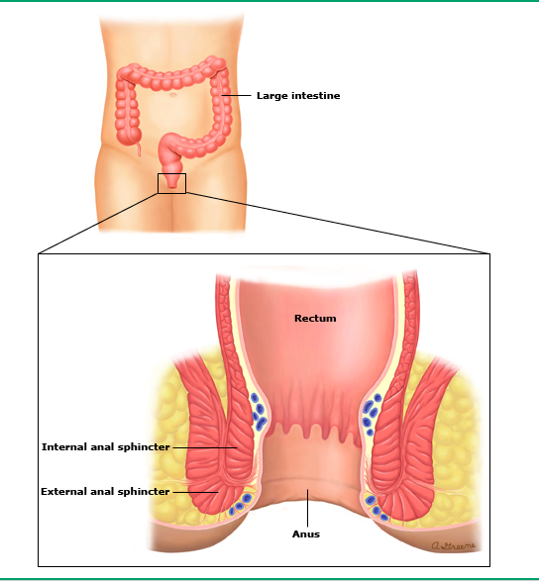

What causes anal fissures?
An anal fissure is most often caused by having a hard, dry bowel movement.
What are the symptoms of an anal fissure?
Most people who have an anal fissure feel a tearing, ripping, or burning pain when they have a bowel movement. This pain can last for hours. Some people also bleed slightly when they have a bowel movement. They might see bright red blood on the toilet paper or on the surface of the bowel movement. Some people with an anal fissure also have itching or irritation around the anus.

Are there tests I should have?
Your doctor or nurse can check whether you have anal fissure by gently spreading your buttocks apart and looking at your anus.
If you have had bleeding, your doctor or nurse might send you for a test called a "sigmoidoscopy" or a similar test called a "colonoscopy" (figure 2). For these tests, the doctor puts a thin tube into your anus and up into your colon. The tube has a camera attached to it, so the doctor can look inside your colon and check for causes of bleeding. The doctor will usually wait until your anal fissure has healed before doing the test.
Colonoscopy versus sigmoidoscopy

During a colonoscopy or a sigmoidoscopy, you lie on your side, and the doctor or nurse puts a thin tube with a camera into your anus (from behind). Then the doctor or nurse advances the tube into the rectum and colon. The camera sends pictures from inside your colon to a television screen.
A colonoscopy allows the doctor to see the whole colon (shown in pink and green). A sigmoidoscopy allows the doctor to see only the last part of the colon (shown in green).

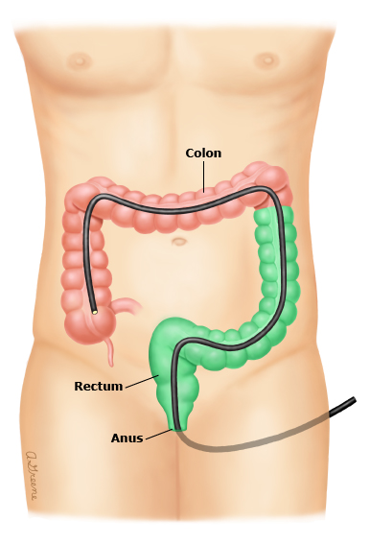

What can I do on my own to help an anal fissure?
You can:
- Eat more fiber – Eating more fiber can help keep your bowel movements soft. Fiber is found in most fruits, vegetables, and whole grains (figure 3). Doctors suggest eating 20 to 35 grams of fiber a day. The nutrition label on packaged foods can show you much fiber you are getting in each serving (figure 4). Additionally, fiber supplements, like Metamucil, can be used to get up to 30g of fiber per day.
- Take a stool softener – Stool softeners are medicines that help make your bowel movements easier to pass. You can buy them without a prescription. One stool softener that is often used is called docusate (sample brand name: Colace).
- Soak your buttocks in a "sitz bath" – Soaking your buttocks in 2 or 3 inches of warm water is called taking a "sitz bath." Do this 2 to 3 times a day for 10 to 15 minutes. Do not add soap, bubble bath, or anything else to the water. Sitz baths help relieve pain and relax the sphincter.

Figure 3:
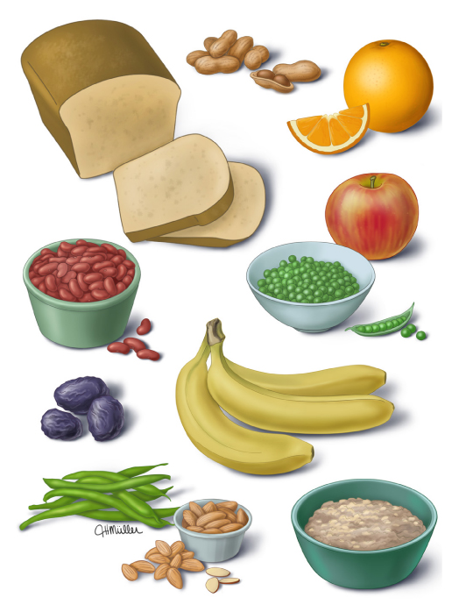

Foods with a lot of fiber include prunes, apples, oranges, bananas, peas, green beans, kidney beans, cooked oatmeal, almonds, peanuts, and whole-wheat bread.

Figure 4

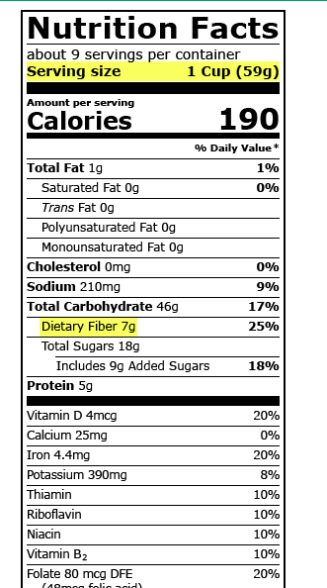

How are anal fissures treated?
Treatment for anal fissures involves steps that are similar to the things you can do on your own.
For the first month of treatment, we will recommend that patients:
- Take fiber supplements, such as:
  - •Psyllium (sample brand name: Metamucil)
  - •Methylcellulose (sample brand name: Citrucel)
  - •Calcium polycarbophil (sample brand name: FiberCon)
  - •Wheat dextrin (sample brand name: Benefiber)
- Take a stool softener, such as docusate (sample brand name: Colace).
- Use nitroglycerin or nifedipine cream, prescription medicines that relax the anal sphincter muscle and help the fissure heal.
    - These medications should be applied about 30 minutes before a bowel movement ~ 3 times per day. It is best to take a warm water bath (above for 10-15 minutes, then apply the nifedipine cream, then have a bowel movement 30 minutes later if possible).
- Take sitz baths (see above).
If these steps to do not work, we can try other treatments, such as:
- Botulinum toxin ("BoTox") – This is a shot that can help the anal sphincter muscle relax and heal. It can help, but it can also cause short-term problems with leaking of gas or bowel movements. This will be allowed to work for a minimum of 6-8 weeks before the doctor can say whether it has or has not worked.
- Surgery – During surgery, the doctor makes a small cut in the sphincter to help it relax. This surgery works in most patients, but doctors offer it only to people who do not get better with other treatments. There is a fairly large (10-30%) chance that the patient may have some incontinence (gas or feces) after the surgery. Surgery can cause lasting problems with leaking of gas or bowel movements.

